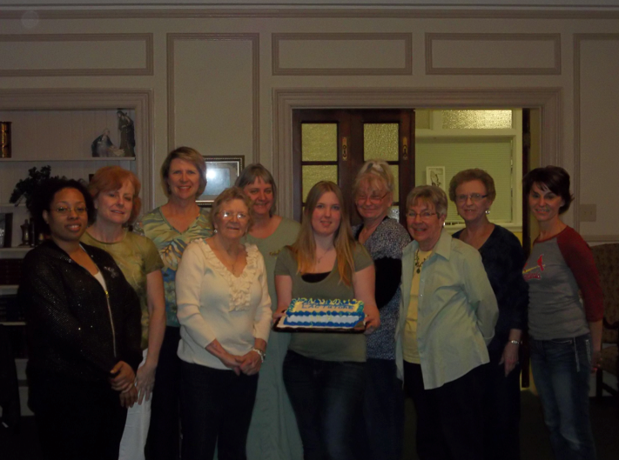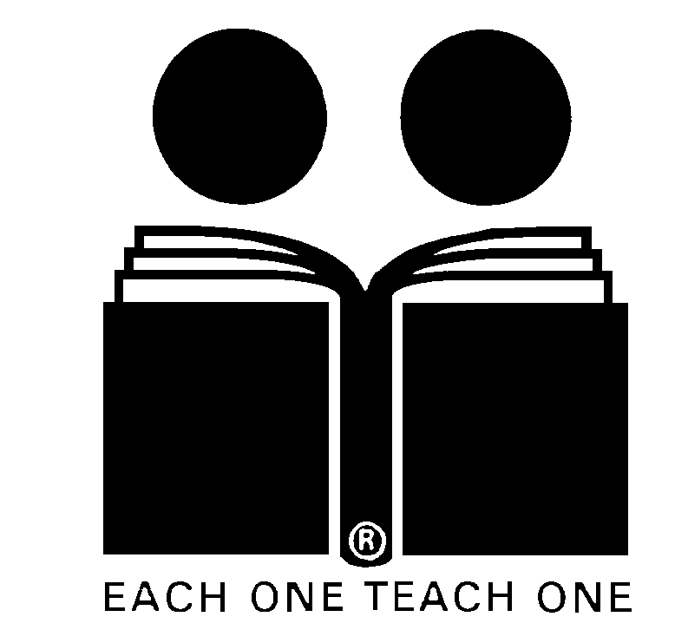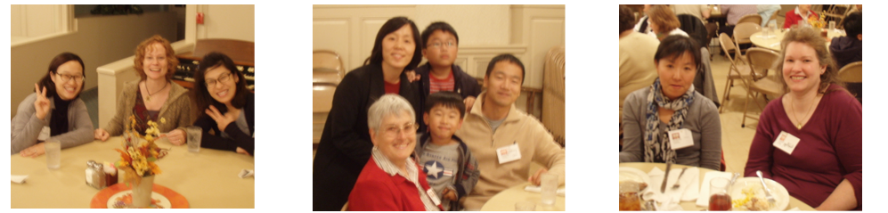

**Congratulations to Advancing Tutors!**

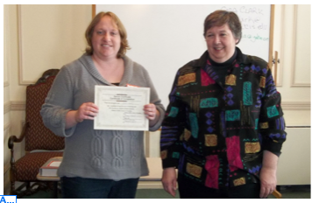

Literacy Action Corps welcomes ten proud graduates to the program. In the English Language Learners program, there were eight new tutors and for Adult Basic Literacy there were two new tutors. The tutors are (from front to back, clock-wise): Emalie Walker, Teresa Cooney, Rita Schulte, Louise Batal, Delcia Crockett, Fern Anderson, Jennifer Turek, Mary Petsel, Tiffany Bounds, and Betty Wilson. Thank you for your commitment to making a difference!

**Mark Your Calendars!**

**NEW**

**Tutor Training Sessions Begin in September**

Literacy Action Corps will host

Tutor training sessions:

**Sept. 18, Sept. 25, Oct. 2, Oct. 9, and Oct. 23**

**First Baptist Church**

**Columbia**

**All** training sessions are required for prospective tutors.

The deadline for registration is **August 14.**

***Mark Your Calendars!***

**Annual Volunteer Appreciation Dinner**

**Tuesday,**

**November 13**

**First Baptist Church**

**Literacy Action Corps  
of Columbia  
P.O. Box 7105  
Columbia, MO  65205  
(573) 442-4280  
[laccolumbia@yahoo.com](mailto:laccolumbia@yahoo.com" \t "_blank)**

**www.literacyactioncorps.com**

**prolit book**

Sara Clark (left) and Joan Dutill (not pictured), received advanced tutoring certificates. Thanks for continuing to make a difference in your students’ lives!

**Introducing Our New Tutors!**

**Congratulations to ten new tutors!**

Fall 2012

**Literacy Action Corps of Columbia**

The Columbia community has generously assisted Literacy Action Corps throughout the year. We thank all of our 2012 donors for their contributions to LAC. The generosity of donors is essential to LAC’s continued success supporting tutors and Adult Basic Literacy and English Language Learner students. Donations go a long way and are put to good use. LAC’s library of training literature and other books represents a significant investment and requires regular updating to stay current. Thank you to each of the donors—your contribution makes a positive impact on the experiences of students and tutors!

**Donations**

**REQUEST FOR INFORMATION FROM TUTORS**

In order to make our annual report to ProLiteracy, we need to know many hours you have spent on LAC tutoring so far in 2012. Included with this newsletter is a Recording and Attendance calendar to be used for recording your tutoring hours. Please complete the enclosed form and deposit in the drop-box at the First Baptist Church – Literacy Corps or mail to: Literacy Action Corps, P.O. Box 7105, Columbia, MO 65205. You may also email the completed form to laccolumbia@yahoo.com. Estimates of time spent with your student are fine. Thank you!

**Tutor Tips and Tools**

Some of the best tutoring techniques come from our fellow tutors. Please share your favorite tips and tools for success to be included in future issues of this newsletter. We can all learn from each other!

E-mail ideas to [LACColumbia@yahoo.com](mailto:LACColumbia@yahoo.com), or send them to LAC at P. O. Box 7105, Columbia, MO, 65205.

When you’re looking for a way to encourage conversations with your students, look no farther than the Columbia Convention and Visitors Bureau. Tutor Andee Gelett uncovered a great teaching tool in the many visitors’ flyers and brochures promoting places to visit around Missouri. Andee collected a number of flyers while volunteering at the Convention and Visitors Bureau to share with students.

Andee shares one flyer at a time with two of **her/his** students. First Andee goes over the flyer to identify any unfamiliar vocabulary. Then **she/he** invites one student to take on the role of tour guide and the other the role of visitor. The “visitor” asks questions such as “Where can we stay overnight?” and “ What activities are there for children” and “Are there any special events?” The “tour guide” uses the flyer to answer. The students can then switch roles.

This exercise is not only a great way to foster dynamic and creative conversation with students, but also an opportunity for learning some Missouri history and finding some fun locations for students to visit with their families!

****

**A very special**

***“THANK YOU!”***

**to our 2012 Donors:**

Boone Electric Community Trust

The First Baptist Church

First Presbyterian Church

R Lawrence & Beth Dessem

James & Carol French

Dayle Garrett

D Gerherdt

Walter & Stacy Peters

Eugene & Viola Powell

Eric and Margaret Thomson

their family are very proud of their achievement. Igor and Lana say their lives have changed for the better, especially since they no longer carry the stress and tension they had before passing the test. Igor and Lana acknowledge that U.S. citizenship is a dream for many people but only some get the opportunity to obtain it and can pass the test. Even U.S.-born citizens would likely have difficulties passing the test! These facts make Igor and Lana appreciate their achievement even more.

Though the path to citizenship has been long, it has been worthwhile for Igor and Lana. As citizens, they are able to stay near their daughter, Yana, and her family in Columbia. Though Columbia isn’t quite the metropolis they are used to, it’s a place they are accepted and can call home.

Thank you to Igor, Lana, and their daughter Yana for sharing their story.

As a way to meet new people and make connections in their new home, Lana began to attend meetings at International

Friends. International Friends became a place of companionship and support. Lana is proud to have befriended the women she met at International Friends. Shirley and Carol especially have been amazing and helpful. International Friends supported Igor and Lana in pursuing their goal of becoming U.S. citizens.

Igor was matched with a tutor to work with once a week in preparation for the citizenship test, while Lana decided to tackle the test on her own. Igor and his tutor worked for an hour a week for four months, question by question. He used memorization, but came to a full comprehension of each question and answer. Flash cards were a very helpful tool for Igor.

Lana approached the test differently. She also went through the test question by question, but instead translated each question and answer to help her fully understand. This method worked best for Lana—so well, in fact, she scored 100 out of 100 questions right.

Igor and Lana’s hard work paid off: after five years of waiting, Igor and Lana realized their dream of becoming American citizens. Igor became a citizen in November 2011 and Lana in May 2012. The couple and

The students who join Literacy Action Corps have different goals. For Igor Lozichniy and Lana Lozichnaya, that goal was American citizenship. Igor and Lana, came to the United States from Baku, the capital of Azerbaijan. They came to Columbia to join their daughter, Yana, who studied at the University of Missouri. The move was also driven by the difficulties the family faced as ethnic Russians living in a Muslim country.

Like many immigrants, Igor and Lana found the process of uprooting their lives and settling in a new locale trying at times. Acclimating to life in Columbia is still sometimes difficult. Igor and Lana have both missed the comfort of close friends as well as the daily, spontaneous interactions with acquaintances and strangers that come with living in a city of nearly two million inhabitants. Lana once described the relative isolation of her new home to friends in Moscow: "Guess what I'm doing? Counting deer in my backyard!" Both Igor and Lana enjoy walking and found the emphasis on using personal cars for transportation a little strange; they were used to walking or taking public transportation to get where they needed. They’ve had to make other adjustments as well, such as living without easy access to entertainment such as the opera.

**Student Success Stories**

If you and your student have a tutoring story or experience to share, please email [laccolumbia@yahoo.com](mailto:laccolumbia@yahoo.com) or mail LAC at P.O. Box 7105, Columbia, MO, 65205.

**An Evening of Appreciation**

The annual Literacy Action Corps Volunteer Appreciation Dinner was held at the First Baptist Church on November 8. Tutors, other volunteers, students, and their families enjoyed a delicious dinner catered by Country Kitchen. The evening was filled with fun and friendship, as attendees participated in a raffle and connected with other tutors and students. Please join LAC in this year’s celebration on November 13!

Thank you, volunteers! Left (left to right): Dongsun Choi, Suzanne Norton, Hyo Joung Lee; center (left to right, top to bottom): Jiyung Jeong, Yejun Shin, Andee Gelatt, Yewon Shin, Jinhong Shin; right (left to right) Seonim Park and Maggie Wong

**Tutoring Success Stories**

rewarding to be the one who shows up for Jerry every week.  We work on his lessons, he reads the stories and writes the exercises very carefully, and I know it's a very meaningful part of his week.  Working on his literacy helps his self-esteem, and I find this a very valuable way to spend my time.  He likes to be someone who works on his skills.  I like being the one who shows up. We both get something out of it.

You always hear people say they get more out of volunteering than they ever expected, and I found this to be true for myself.  Sometimes tutoring is about helping someone acquire a new skill or a new language, and sometimes maybe it's just about being that person that shows up.

I love being a literacy tutor.  I know Jerry appreciates it.  That's good enough for me.

I wanted to share our story in case it might inspire someone else to become a tutor.  You just never can understand the rewards until you've done it yourself.

\*Names changed by request. Thanks to Norma and Jerry.

**Congratulations to Advancing Tutors**

Sara Clark (left) and Joan Dutill (not pictured), received advanced tutoring certificates. Thanks for continuing to make a difference in your students’ lives!

Instead I have found it rewarding to be the one who shows up for Jerry every week. We work on his lessons, he reads the stories and writes the exercises very carefully, and I know it's a very meaningful part of his week. Working on his literacy helps his self-esteem, and I find this a very valuable way to spend my time.  He likes to be someone who works on his skills.  I like being the one who shows up. We both get something out of it.

You always hear people say they get more out of volunteering than they ever expected, and I found this to be true for myself.  Sometimes tutoring is about helping someone acquire a new skill or a new language, and sometimes maybe it's just about being that person that shows up.

I love being a literacy tutor.  I know Jerry appreciates it.  That's good enough for me.

I wanted to share our story in case it might inspire someone else to become a tutor.  You just never can understand the rewards until you've done it yourself.

\*Names changed upon request.

Thanks to Norma and Jerry for sharing their story.

One of Literacy Action Corps’ Adult Basic Literacy tutors, Norma Greene\*, shares her tutoring experience and what the tutoring relationship means to her and her student.

I've been tutoring Jerry\* for 2 or 3 years.  He's 30 years old now, developmentally disabled, and living independently in an apartment of his own.  I don't know for sure what all his limitations are.  I think there are some visual issues, some auditory issues, and some cognitive issues.  I don't think he'll ever be able to read a whole book by himself, but he's good with numbers, recognizes some words easily, knows his alphabet, reads signs well, and with my help makes it through the stories and exercises in the Laubach books.  He copies words and passages from the Bible, and likes doing that to pass his time.  We are working our way through the Laubach series slowly.  He enjoys the time we spend together.  I sometimes think I am the only one who regularly shows up for him. I went into this whole tutoring thing thinking I would be teaching one student for a while and that once they got a handle on reading I'd start with another student, then another, and so on. Instead I have found it

Literacy Action Corps of Columbia is a non-profit organization founded in 1968. It is affiliated nationally with ProLiteracy Worldwide, and is governed by a volunteer Board of Directors.